Exp3-DML commands(insert,select,update,delete)

1)insert:

mysql> create table student(regno int, name varchar(255),grade varchar(10));

Query OK, 0 rows affected (0.12 sec)

mysql> insert into student values ('112','monish','s');

Query OK, 1 row affected (0.04 sec)

mysql> insert into student values('113','harish','s');

Query OK, 1 row affected (0.04 sec)

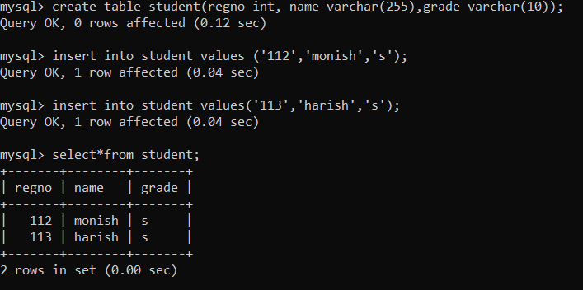

2)select:

mysql> select\* from student where regno='112';

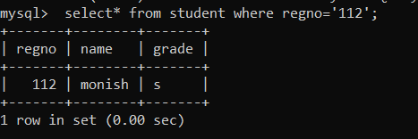

3)update

mysql> update student set name='kumar' where regno='112';

Query OK, 1 row affected (0.04 sec)

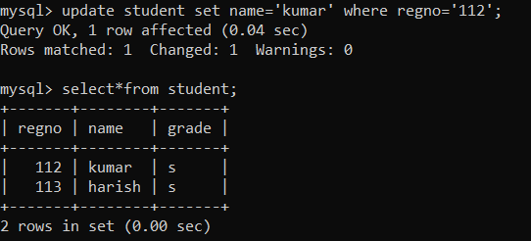

4)delete:

mysql> delete from student where regno='113';

